# Introduction

The Document intend to produce steps for byInspired-Library ( IOS ) integration at the developers dispose as how to integrate , develop & test the creatives by Inspired Mobile Ltd.

|  |  |
| --- | --- |
| LIBRARY | Technology / Platform |
| Mraid 1.0.3 | Developed with Native XCdoe 9.1  Swift 4.0  Ideal for developers who has XCode 9.1  Minimum IOS version 11.0 required |

# Resources

|  |  |  |
| --- | --- | --- |
| LIBRARY | Cocoapods | Github Repo |
| MRaid 1.0.3 | [MRaid Pod](https://cocoapods.org/pods/Mraid) | [Mraid Repo](https://github.com/hexims/Mraid) |

# Instructions

Set of instructions are provided MRaid 1.0.5 , XCode 10.1 , Minimum Target version IOS 9.0 , Maximum targeted version IOS 12.0

## 

* XCode 10
* Swift 4.0
* Terminal
* Cocoa pods

1. Create a new project in Swift
2. Close the New project you have just created and open terminal.app
3. Follow the Steps

|  |  |
| --- | --- |
| No. | Command |
| 1 | Browse in to your directory where you have created app from XCode  cd <Inside Project Directory>  For Example: $ cd /Users/aj/desktop/demobyinspired/demoApp |
| 2 | We will now need to use cocoapods , in order to fetch Library provided by Inspire Mobile Ltd. For this we will need to follow following steps , pod init will initialize a pod file where we will than need to put the library name we desire , here we need MRaid 1.0.5 ,  Steps / instructions are available at ( Click on Instruction / Guide ) :  https://cocoapods.org/pods/Mraid    pod init  open podfile  ( this will open up your pod file in editor with the following code )    enter above end : pod 'Mraid', '~> 1.0'    Save and close the file   |  | | --- | | Once you press enter – this command gets executed and thereafter fetches MRaid1.0.3 Library from cocoapods  All you need to do is sit and relax till this is finished  On your terminal in same window – enter  pod install  reference image from terminal : | |
| 5 | Now you may close the terminal and open your project folder  Which will than show you a .xcworkspace file And pods  You now can start your project by opening .xcworkspace file but do not start your project with .xcodeproj ( as now this is a workspace which has pod integration)  In our case this is DemoApp.xcworkspace |
|  | Now you project is ready and has been integrated with MRaid1.0.5 Library |

# 

# Setup

Files we will need to integrate

* AppDelegate.swift
* ViewController.Swift
  + This can be any controller where you need to integrate the creative
    - This is banner creative for 320x250
* InterstitialViewController.swift
  + For demo purpose we have named this controller as InterstitialViewController.swift it can be any viewcontroller where you need Interstitial Creative to come
    - This is full screen creative
* banner.html
  + this file is supplied in pods , you will need to drag this file from pod to your project directory
    - this step is mandatory
      * 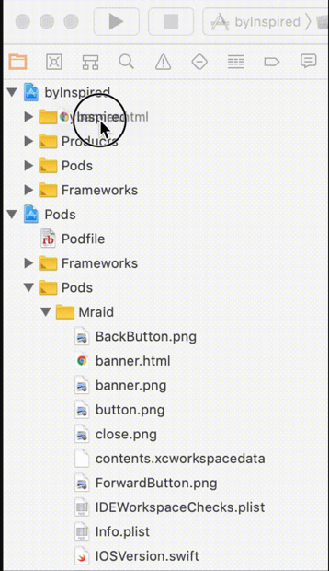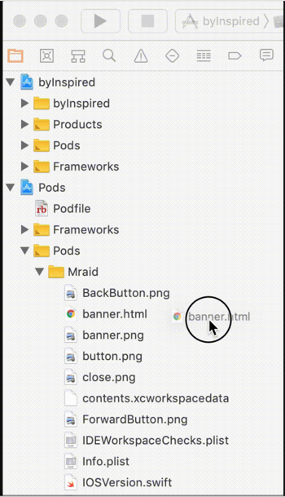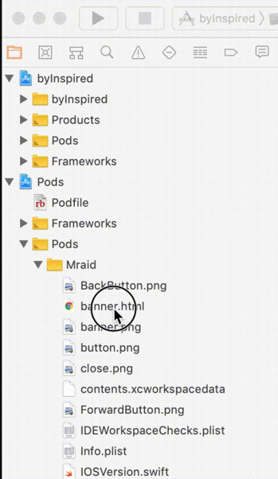Example :

# Code Integration

Let’s get started

## AppDelegate.swift

Open file AppDelegate.swift in your xcode

Define the following ( add the following code ) under var window : UIWindow?

**class** AppDelegate: UIResponder, UIApplicationDelegate {

**var** window: UIWindow?

**var** bannerKey = NSString()

**var** bannerTag = NSString()

**var** interstitialKey = NSString()

**var** interstitialTag = NSString()

**var** ifChina = Bool()

Enter the following code in fun accplication

ifChina = **true**

*// for banner 320 x 50*

bannerKey = "Enter your Banner key"

bannerTag = "Enter your banner Tag"

*// full screen*

interstitialKey = "Enter your Interestial Cretive Key"

interstitialTag = "Enter your Interestrial Tag"



## ViewController.swift

Open your view controller file – this can be any view controller where you need the creative to be added , you will need to use the following code integration

For working sample inspire has provided sample app which you can than run and test.

### Steps

1. **import** Mraid
2. Add the following code in your class ViewController
3. UIViewController,SKMRAIDViewDelegate,SKMRAIDServiceDelegate,SKBrowserDelegate,SKMRAIDModalViewControllerDelegate,UITextFieldDelegate

Reference image :



1. Declarations in view controller class

**var** app = AppDelegate()

**var** adView = SKMRAIDView()

**var** browser = creative()

**var** bannerOpenString = NSString()

**var** tagNmbr = NSString()

**var** keyString = NSString()

**var** domain = NSString()

1. viewDidLoad()

app = UIApplication.shared.delegate **as**! AppDelegate

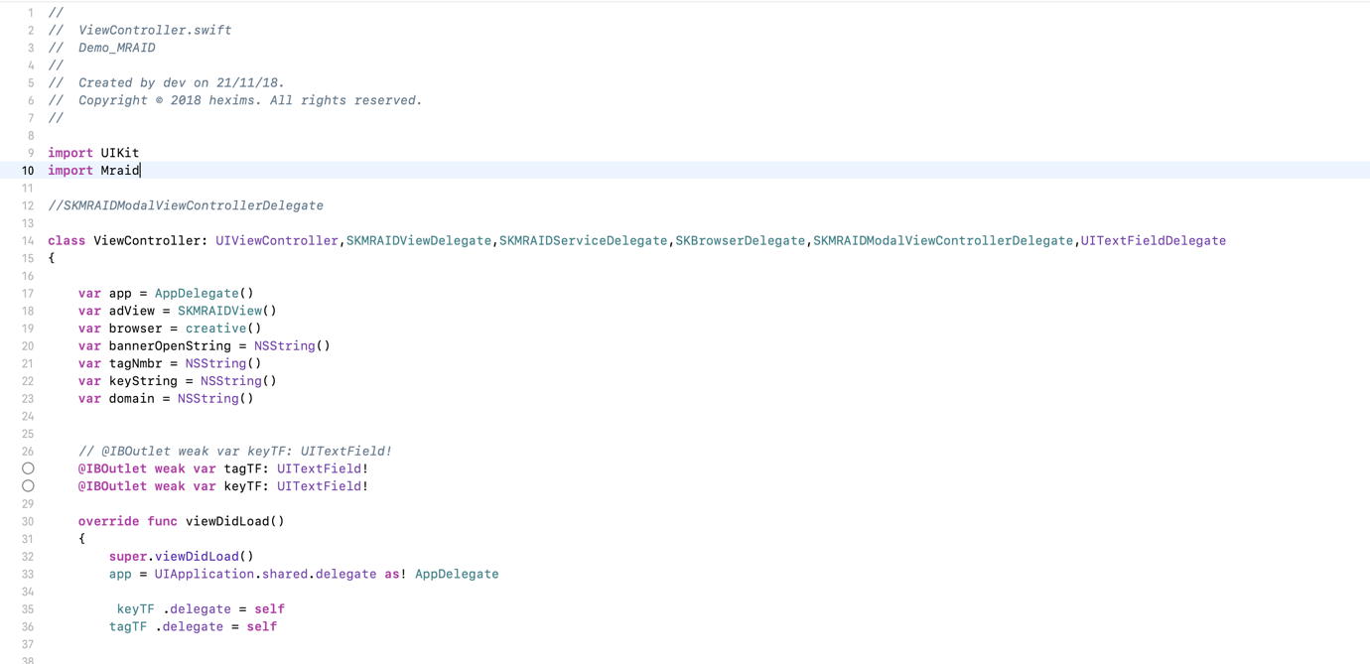

1. Now it is important to call the banner creative , as per your usage you may call this function either on click of a button or on a timer based event ,
   * + - For instance suppose you need to call this on the click of a button where you will need to create button ( we assume you must be aware how to do that)

Copy paste this code to read your key and tag for banner on your button click

tagNmbr = String(format: "tag=\"%@\"",app.bannerTag) **as** NSString

keyString = String(format: "key=\"%@\"",app.bannerKey) **as** NSString

**if** app.ifChina == **true**

{

domain = String(format: "src=\"%@\"","https://cdn.inspired-mobile.cn/fenix.js") **as** NSString

}

**else**

{

domain = String(format: "src=\"%@\"","https://cdn1.inspired-mobile.com/fenix.js") **as** NSString

}

DispatchQueue.main.async {

// banner function which will execute creative

**self** .showBannerData()

}

1. Show Banner Data Function (copy the following code)

**func** showBannerData()

{

**do** {

**guard** **let** filePath = Bundle.main.path(forResource: "banner", ofType: "html")

**else** {

print ("File reading error")

**return**

}

**var** htmlData = **try** String(contentsOfFile: filePath, encoding: .utf8)

print(htmlData)

htmlData = htmlData.replacingOccurrences(of: "src=\"\"", with: domain **as** String)

print(htmlData)

htmlData = htmlData.replacingOccurrences(of: "tag=\"\"", with: tagNmbr **as** String)

print(htmlData)

htmlData = htmlData.replacingOccurrences(of: "key=\"\"", with: keyString **as** String)

print(htmlData)

bannerOpenString = htmlData **as** NSString

**let** bundleUrl = NSURL(fileURLWithPath: Bundle.main .bundlePath)

adView.frame = CGRect(x: 0, y: 0, width: **self**.view.frame.size.width, height: 100)

adView = adView .initWithFrame(frame: CGRect(x: 0, y: 0, width: **self**.view.frame.size.width, height: 100), withHtmlData: bannerOpenString, withBaseURL: bundleUrl, supportedFeatures: [Constants.MRAIDSupportsSMS, Constants.MRAIDSupportsStorePicture], delegate: **self**, serviceDelegate: **self**, rootViewController: **self**) **as**! SKMRAIDView

**self**.view .addSubview(adView)

}

**catch** {

print ("File HTML error")

}

}

// this sample code can be obtained from Sample app along with Supplied Library

Mandatory Functions for Mraid to function – needs to be implemented ( copy & Paste)

*//********************DELEGATE METHOD START\*\*\*\*\*\*\*\*\*\*\*\*\*\*\*\**

*//If Mraid Ready*

**func** mraidViewAdReady(mraidView: SKMRAIDView)

{

print("")

}

*//If Mraid Failed*

**func** mraidViewAdFailed(mraidView: SKMRAIDView)

{

print("")

}

*//If Mraid Expand*

**func** mraidViewWillExpand(mraidView: SKMRAIDView)

{

print("")

}

*//If Mraid Closed*

**func** mraidViewDidClose(mraidView: SKMRAIDView)

{

print("")

}

*//If Mraid Navigate with url*

**func** mraidViewNavigate(mraidView: SKMRAIDView, withURL url: NSURL) {

print("")

}

**func** MRAIDForceOrientationFromString(s: NSString) -> SKMRAIDForceOrientation

{

**return** SKMRAIDForceOrientation.MRAIDForceOrientationPortrait

}

**func** mraidViewShouldResize(mraidView: SKMRAIDView, toPosition position: CGRect, allowOffscreen: Bool) -> Bool

{

**return** **true**

}

*//If Mraid is "open"*

**func** mraidServiceOpenBrowserWithUrlString(urlString: NSString) {

browser = browser .initWithDelegate(delegate: **self**, withFeatures: [Constant.kSourceKitBrowserFeatureSupportInlineMediaPlayback

, Constant.kSourceKitBrowserFeatureDisableStatusBar

, Constant.kSourceKitBrowserFeatureScalePagesToFit]) **as**! creative

**let** myURL = URL(string: urlString **as** String)

**let** myRequest = URLRequest(url: myURL!)

browser .loadRequest(request: myRequest **as** NSURLRequest)

}

*//If Mraid Storepicture*

**func** mraidServiceStorePictureWithUrlString(urlString: NSString)

{

print("")

}

**func** mraidModalViewControllerDidRotate(modalViewController: SKMRAIDModalViewController)

{

print("Rotate")

}

*//If Mraid Closed from browser*

**func** sourceKitBrowserClosed(sourceKitBrowser: creative) {

**self** .dismiss(animated: **true**)

{

**self** .navigationController?.popViewController(animated: **true**)

}

}

Exit App from Browser

**func** sourceKitBrowserWillExitApp(sourceKitBrowser: SKBrowser2)

{

print("")

}*//********************DELEGATE METHOD END\*\*\*\*\*\*\*\*\*\*\*\*\*\*\*\*\*\**

## Interstitial Creative

For interstitial adverts you can integrate and follow the code below where you need to have full screen Interstitial Creatives , the below integration is important therefore we have supplied the same in sample code which can be used as a reference.

1. **import** Mraid
2. Add following delegate methods on your controller class

UIViewController,SKMRAIDServiceDelegate,SKMRAIDInterstitialDelegate

In the example we have InterestitialViewController , example below :

**class** InterstitialViewController:

{

1. Declarations in your controller class :

**var** app = AppDelegate()

**var** interstitiaOpenString = NSString()

**var** interstitial = SKMRAIDInterstitial()

**var** tagNmbr = NSString()

**var** keyString = NSString()

**var** domain = NSString()

viewDidLoad()

app = UIApplication.shared.delegate **as**! AppDelegate

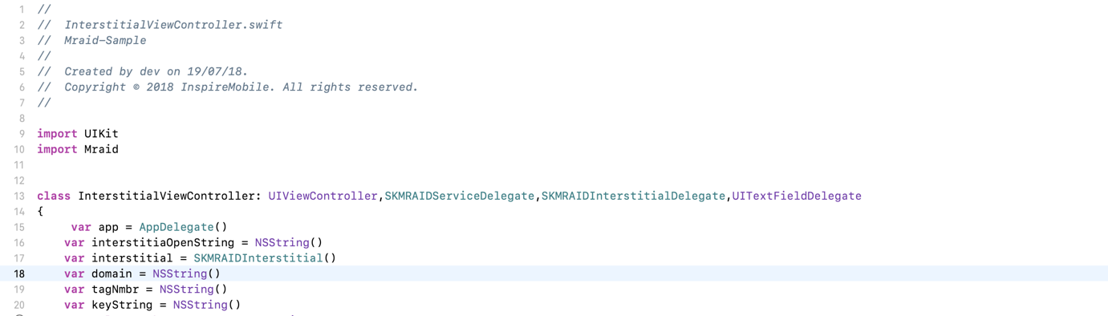

you may also call / add tags and key on viewDidLoad in order for the controller to initiate , or you may have it on click of button

tagNmbr = String(format: "tag=\"%@\"",app.interstitialTag) **as** NSString

keyString = String(format: "key=\"%@\"",app.interstitialKey) **as** NSString

**if** app.ifChina == **true**

{

domain = String(format: "src=\"%@\"","https://cdn.inspired-mobile.cn/fenix.js") **as** NSString

}

**else**

{

domain = String(format: "src=\"%@\"","https://cdn1.inspired-mobile.com/fenix.js") **as** NSString

}

//to call the function you may either pass in viewDidload or on event click as where you need :

**self** .showInterstitial()

// in sample app we have made buttons to call the advert for demo purpose only , you may do it as per your usage

1. Important functions : you may copy paste the following or refer to sample app for the same :

*//********************** INTERSTITIAL START \*\*\*\*\*\*\*\*\*\*\*\*\*\*\*\*\*\*\*\**

**func** showInterstitial()

{

**do** {

**guard** **let** filePath = Bundle.main.path(forResource: "banner", ofType: "html")

**else** {

print ("File reading error")

**return**

}

**var** htmlData = **try** String(contentsOfFile: filePath, encoding: .utf8)

print(htmlData)

htmlData = htmlData.replacingOccurrences(of: "tag=\"\"", with: tagNmbr **as** String)

print(htmlData)

htmlData = htmlData.replacingOccurrences(of: "key=\"\"", with: keyString **as** String)

print(htmlData)

htmlData = htmlData.replacingOccurrences(of: "key=\"\"", with: keyString as String)

print(htmlData)

interstitiaOpenString = htmlData **as** NSString

**let** bundleUrl = NSURL(fileURLWithPath: Bundle.main .bundlePath)

**let** bundleUrl = NSURL(fileURLWithPath: Bundle.main .bundlePath)

interstitial = interstitial .initWithSupportedFeatures(features: [Constants.MRAIDSupportsSMS, Constants.MRAIDSupportsStorePicture, Constants.MRAIDSupportsInlineVideo], withHtmlData: interstitiaOpenString , withBaseURL: bundleUrl, delegat: **self**, serviceDelegat: **self**, rootViewControllerr: **self**) **as**! SKMRAIDInterstitial

}

**catch**

{

print ("File HTML error")

} }

## Interstitial Important Delegate Functions

*// Mraid Interstitial Open With Url*

**func** mraidServiceOpenBrowserWithUrlString(urlString: NSString)

{

**if** **let** url = URL(string: "\(urlString)")

{

**if** **#available**(**iOS** 10.0, *) {

UIApplication.shared.open(url, options: [:], completionHandler: **nil**)

} **else** {

*// Fallback on earlier versions*

}

}

}

**func** mraidServiceStorePictureWithUrlString(urlString: NSString)

{

print("LOG")

}

*// Mraid Interstitial Ready*

**func** mraidInterstitialAdReady(mraidInterstitial: SKMRAIDInterstitial)

{

interstitial .show()

}

*// Mraid Interstitial Failed*

**func** mraidInterstitialAdFailed(mraidInterstitial: SKMRAIDInterstitial)

{

print("Failed")

}

*// Mraid Interstitial Will Show*

**func** mraidInterstitialWillShow(mraidInterstitial: SKMRAIDInterstitial)

{

print("")

}

*// Mraid Interstitial Hide Not Ready*

**func** mraidInterstitialDidHide(mraidInterstitial: SKMRAIDInterstitial)

{

print("Status: Not Ready")

**self**.navigationController?.popViewController(animated: **true**)

}

**func** mraidInterstitialNavigate(mraidInterstitial: SKMRAIDInterstitial, withURL url: NSURL)

{

}

*//********************DELEGATE METHOD END\*\*\*\*\*\*\*\*\*\*\*\*\*\*\*\*\*\**

**func** textFieldShouldReturn(**_** textField: UITextField) -> Bool

{

textField.resignFirstResponder()

**return** **true**;

}

XCode Settings :

If Case are using XCode 10 , swift 4.2 and wish to use Mraid 1.0.3 Libray you will than need to do the following settings in you XCode in order to run the Libray

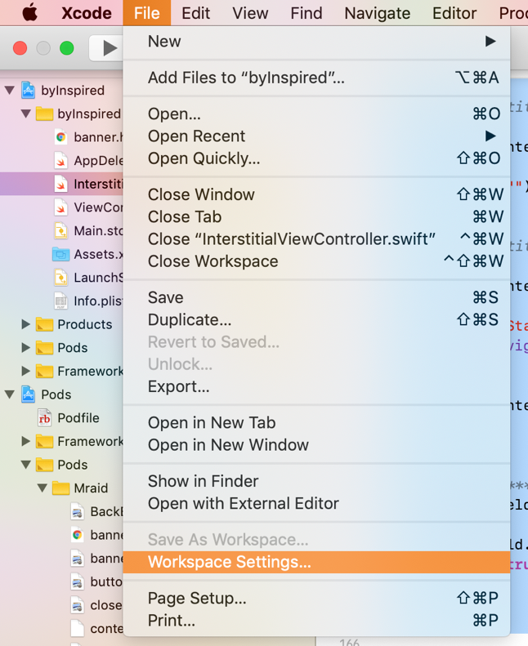 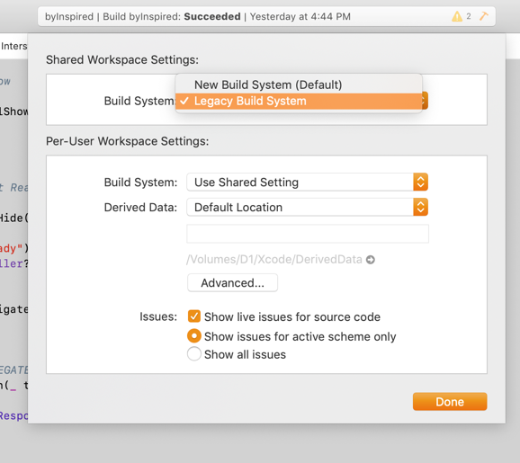

Select Project > Select Target > Build Settings > Search for “Swift Compiler – Language”

Choose version 4.0

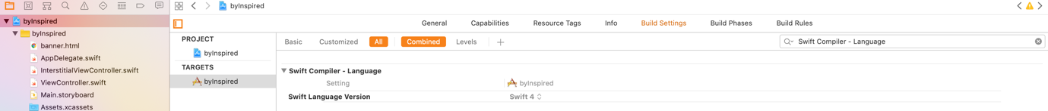

Same you will need to do it for Pods

Select Pods > Select Target > Build Settings > Search for “swift language version”

Choose version 4.0

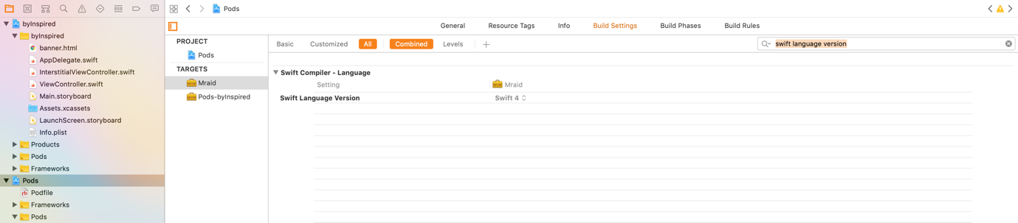

LASTLY in your plist don’t forget to add app transport settings



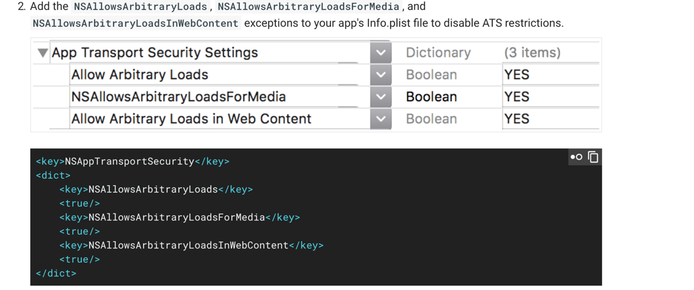

Recommendation :

The Project Swift version = 4.0

POD swift version = 4.0

These both needs to be same

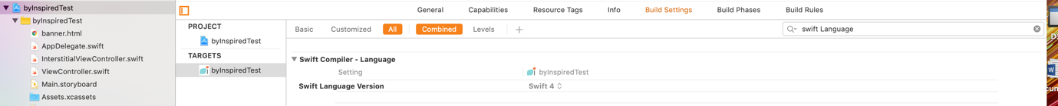



Target Version need to be IOS 9.0 for both pods and Project

